Name: |  | Phone:
Email: |  | www:

This sheet is the same as our staff use to ensure all factors are considered to get you the best machine type and model to bring a smile to your business.
The benefit of going through this checklist with us on a Teams call is that we can help you “weigh” your answers and give you a formal quote at the end. It takes 15 minutes, and you will live with your choice for years to come. Why not call us now?

Acquisition  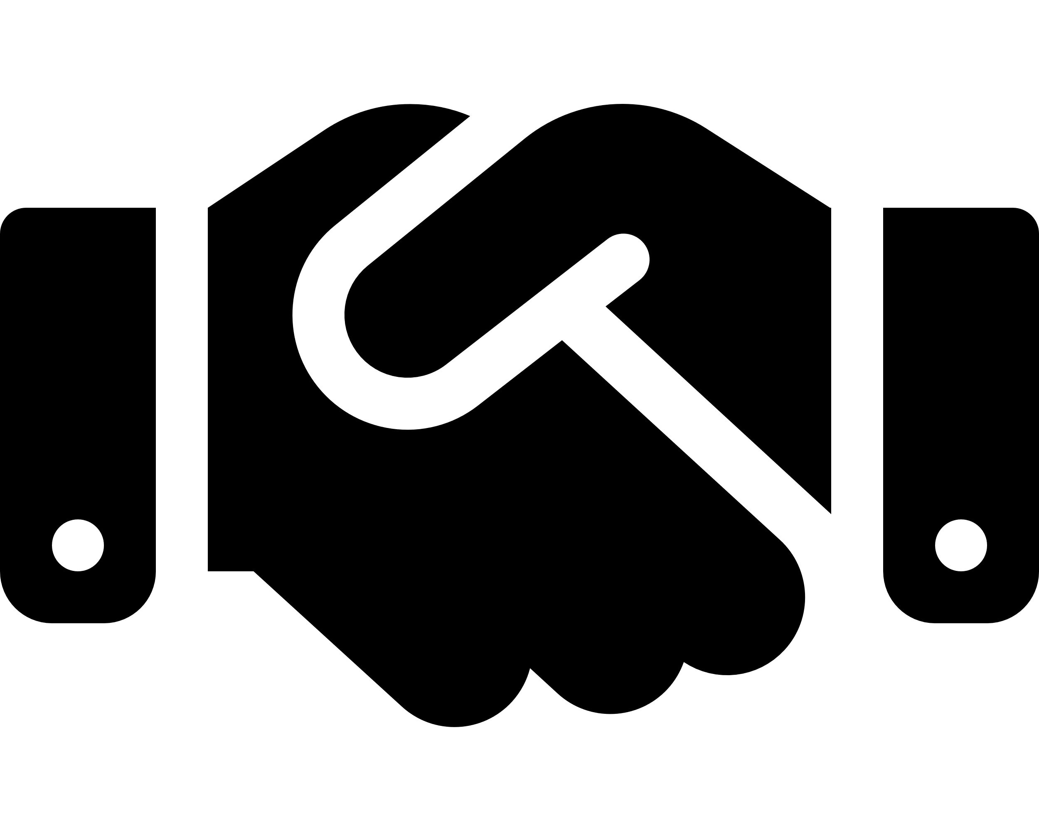 | Budget: | Desirable  £ | Maximum  £
 | Lease or Purchase:  You can own the equipment at the end of the lease for a small admin fee of just £150 | Choose an item.
 | Preferred installation date:

Installation  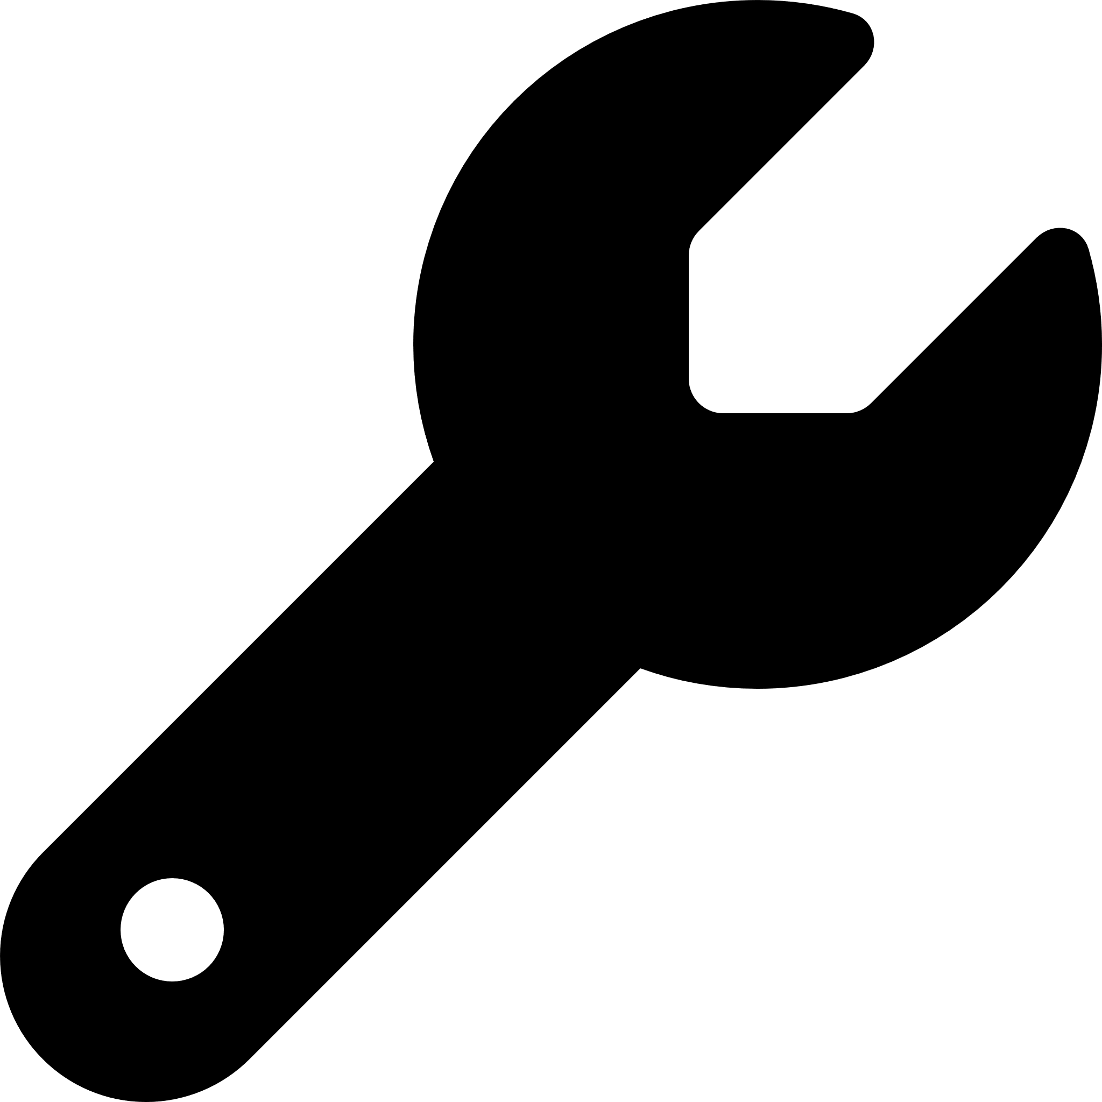 | Water source: | -- Please Select --
 | Water waste:  Choose to have wastewater  direct to mains or to an  under-counter container. | -- Please Select --
 | Power source available:  Power needs to be within  1M of the machine. | -- Please Select --
Positioning:
Is there a need for a coffee cart or coffee station?

Drink  Options  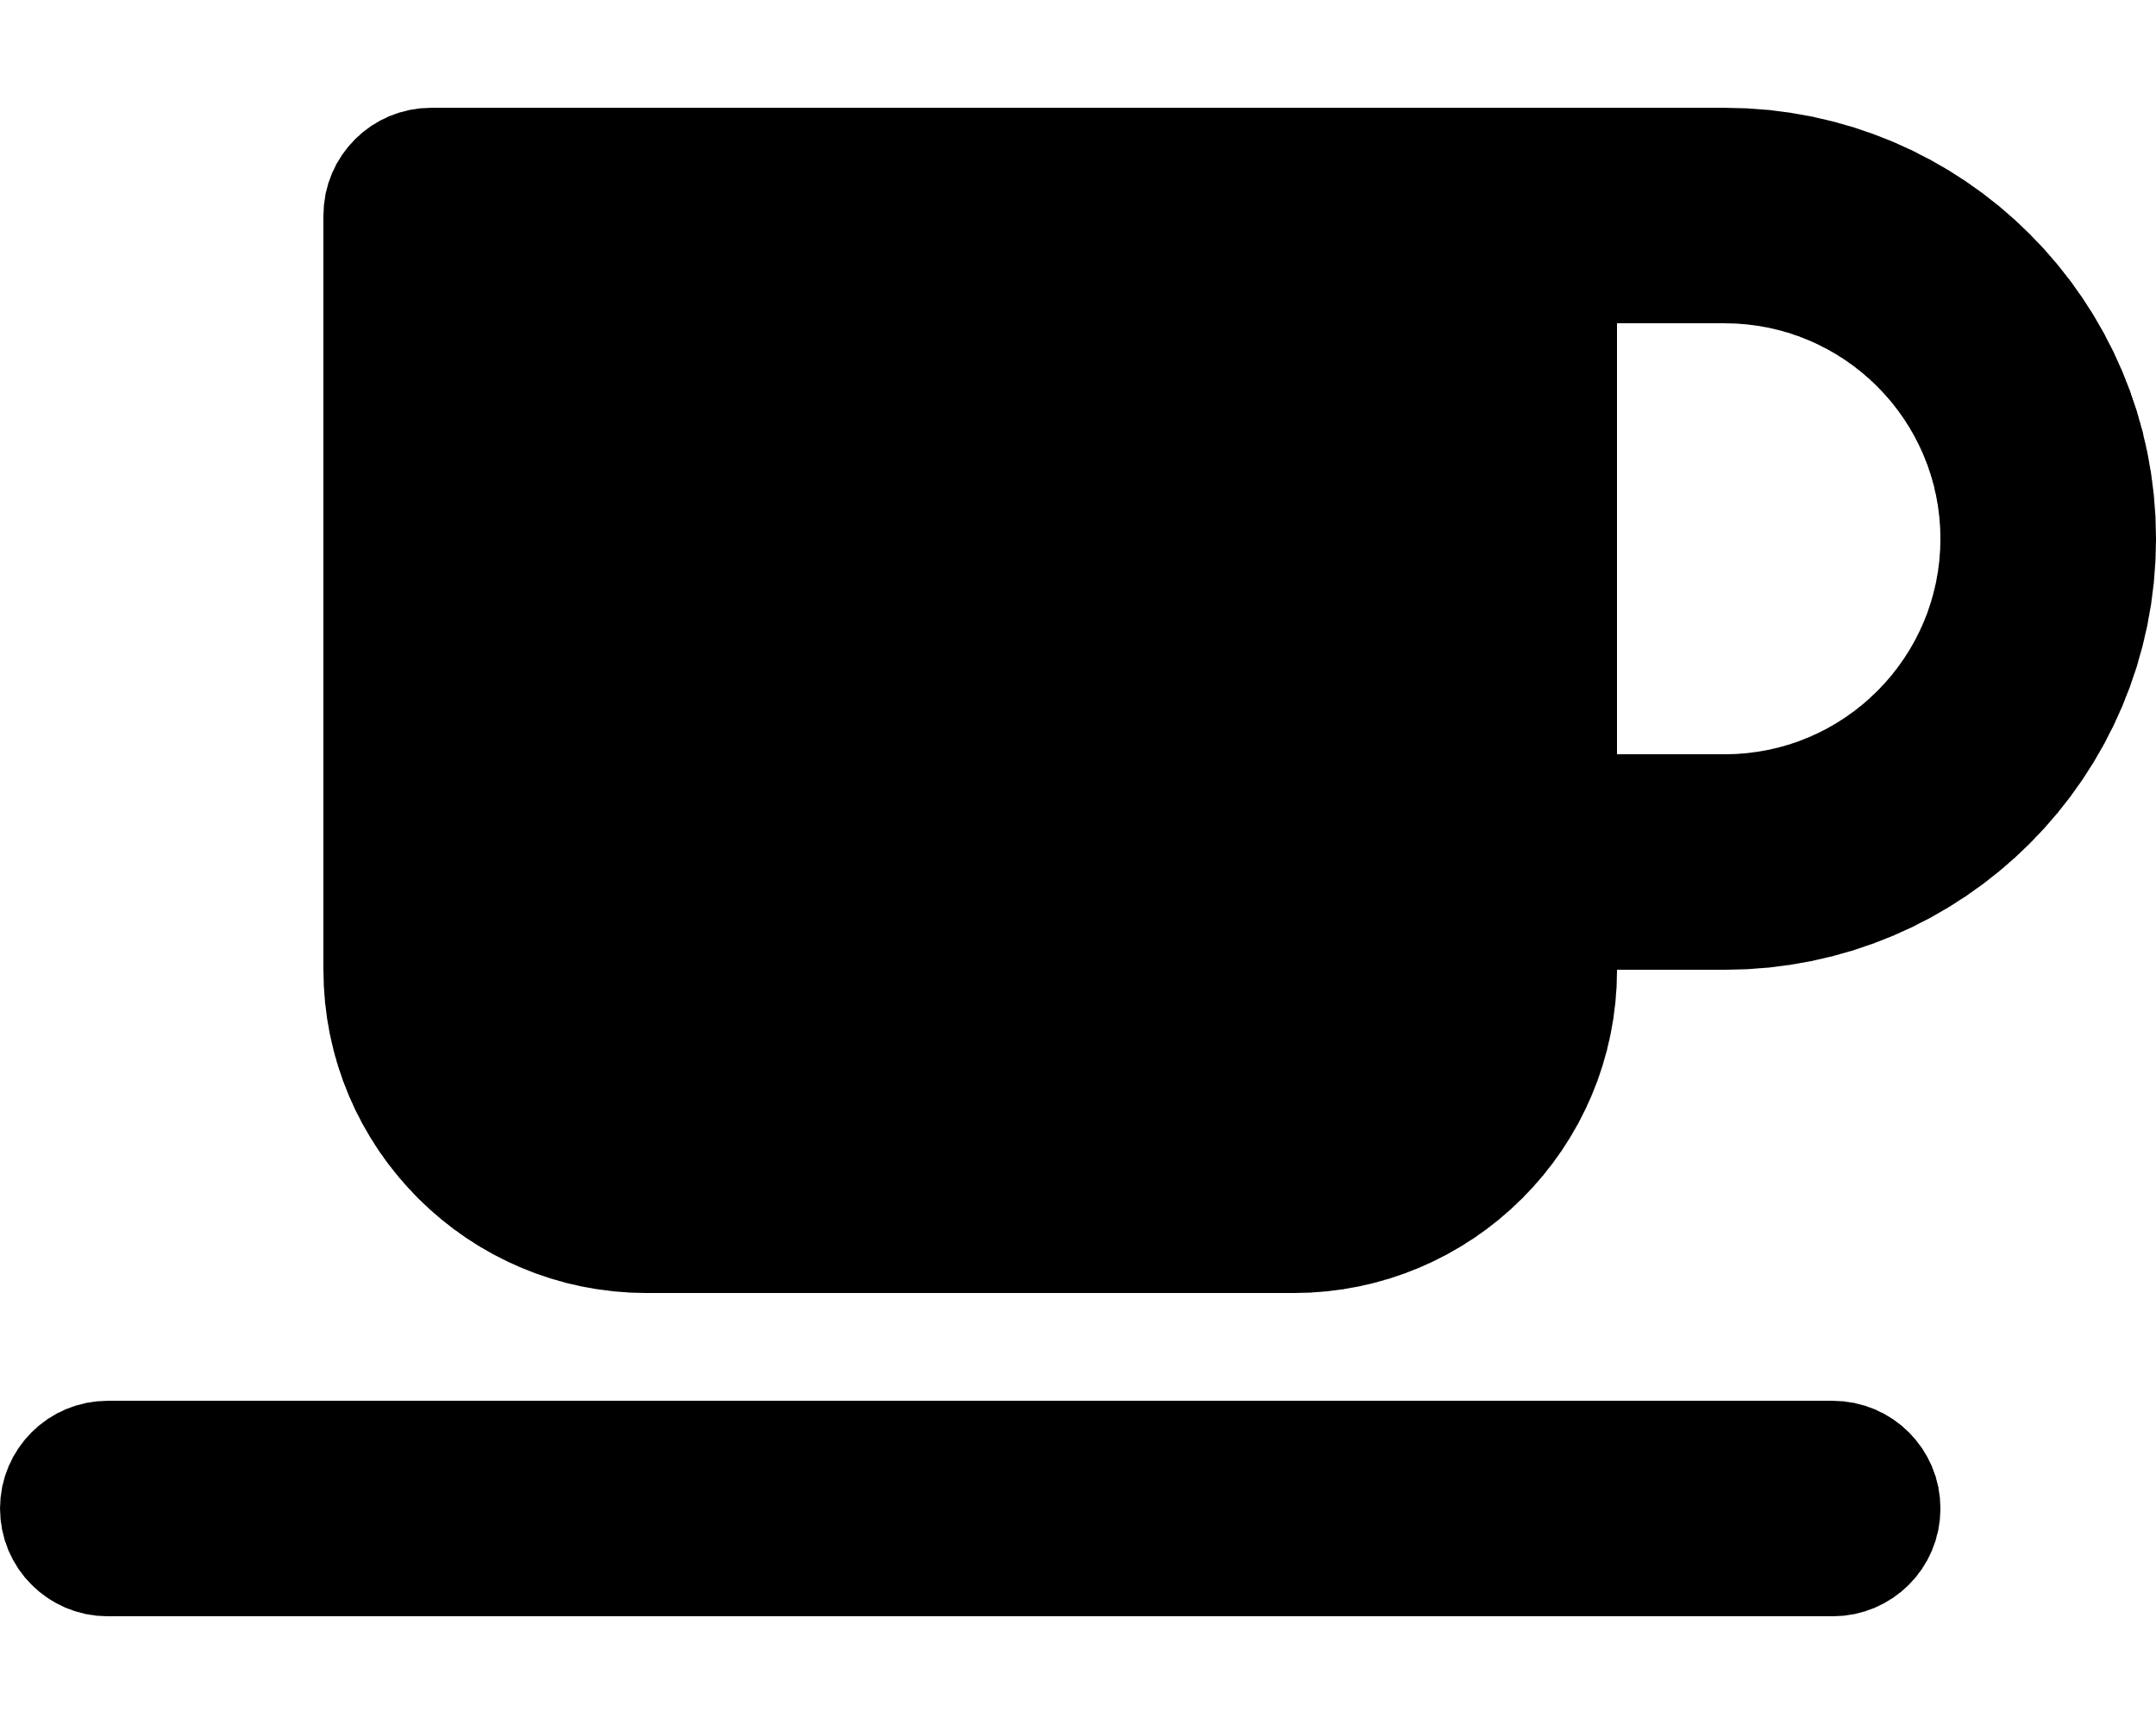 | Quality of drinks:  Good Milk Foam - ideal for small bars & offices.  Barista quality Milk Foam - for premium office, reception areas and venues wanting to sell  take-away size drinks. | -- Please Select --
 | No of drinks per day? | -- Please Select --
Drink  Options | No of drinks at peak times?  Some machines are faster  than others. | -- Please Select --
 | Takeaway drinks? (12oz) | -- Please Select --

Fresh Milk or Granulated:
Fresh milk provides superior foam and taste. Granulated offers great value, speed, and less maintenance.
 | Is Decaf coffee required? | -- Please Select --
 | Is Hot Chocolate required? | -- Please Select --
 | Is an option for Alternative Milk required? | -- Please Select --
 | Style of coffee required:  Bean to cup machines work best with less oily beans. Indigo Valley have three styles to choose from | -- Please Select --

Vending  Options   | - Self Service:  - Free Vend  With Payment System | -- Please Select --
 | - Operator service:  Fully automatic: press the button only.  Semi-automatic: with a steam wand for milk and for non-dairy. | -- Please Select --

Further comments:
Some manufacturers say they can do non-dairy as a fully automated option system. We are a little unsure about these claims.

Level of Maintenance | All-inclusive Maintenance:  Includes planned annual servicing and emergency callouts, parts & labour. | Choose an item.
 | - Planned Annual servicing:  Includes annual machine inspection and water filter exchange only. | Choose an item.
 | - Pay As You Go:  All servicing and maintenance paid as and when required. | Choose an item.

FAQ

Q: What is the cost of a drink?
Each machine can be programmed to make a drink the way you want, which means the volume of ingredients will be variable. However, here is a rough guide.
- Espresso and long black: 15p
- Long white: 28p
- Cappuccino and latte: 40p if fresh milk
- Hot chocolate: 35p

Q: What is the average life of a bean-to-cup machine?
5 to 10 years; the most significant longevity factors are the number of drinks produced AND the daily maintenance of the machine.

Q: Is an annual service required, and if so, what is the cost commitment?
Each machine is different. Please check with the manufacturer.
Q: Can I purchase an extended warranty, and if so, what does it cover and cost?
Yes, but; Each machine is different. Please check with the manufacturer.

 | how much carbon  is in your coffee?
 | Indigo Valley catches 96% at the roast. To find out simply check out our Carbon Calculator by scanning the QR code | 

